Action Plan (initial and mid-point)

Candidate name:

Use this plan to outline the key activities you plan to undertake to build your SEPAR hours before your next portfolio submission.
- Please be as specific as possible in the information you provide, so it is clear to reviewers how you plan to reach your target competencies.
- Add / delete rows to suit your needs.
- You may also wish to attach a Gantt chart, to provide a visual illustration of what you plan to do and when (optional).
Note: What you write on this plan does not have to be set in stone, so reviewers will understand if what you write here ends up changing. The purpose of this is to show you have thought about how you will achieve your required SEPAR hours and that you have ideas and/or plans in place to help you get there.

Plans for Application/Consultancy Hours
Use this section to outline any current applied work you are involved in, as well as any applied work you are in the process of setting up, or ideas you have that you would like to try and pursue.
Organisation and/or client group | Role and description of work you will/hope to be doing | Timescales (i.e., when is the work likely to start/finish?) | Is this placement already in place? | What are your next steps to action this? (if applicable)

Plans for Dissemination and Citizenship Hours
Use this section to outline the activities you plan to undertake to accrue your dissemination and citizenship hours over the upcoming period, and/or ideas you have for gaining relevant experiences. In preparing this plan, please consult the Candidate Handbook as a reminder of activities that fall under Dissemination and Citizenship.
Activity | Description of what you plan to do and who this will involve working with | Timescales (i.e., when is this likely to happen?) | What are your next steps to action this?

Plans for CPD and Supervision Hours
Use this section to outline the activities you plan to undertake to accrue your CPD and supervision hours over the upcoming period, and/or ideas you have for gaining relevant experiences. In preparing this plan, please consult the Candidate Handbook as a reminder of activities that fall under CPD and Supervision.
Activity | Type of activity | Main competencies targeted  (list numbers) | Timescales  (i.e., when do you plan to do this?) | Any steps needed to action this? (e.g., booking a course)
 | Choose an item.
 | Choose an item.
 | Choose an item.
 | Choose an item.
 | Choose an item.
 | Choose an item.
 | Choose an item.
 | Choose an item.

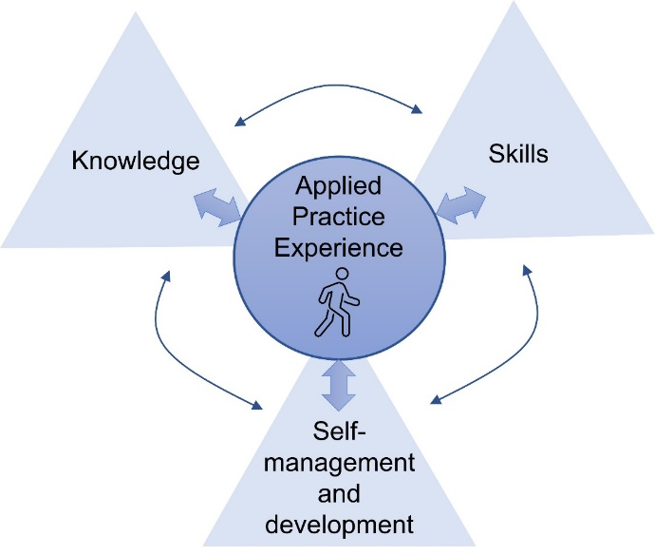
Action plan statement
Figure 2 from Candidate Handbook
Please outline how the activities above will enable you to reach your target competencies in each area.
As outlined in Figure 2 in the Candidate Handbook (see right), applied practice experience is at the heart of your development. Therefore the experience section comes first, as you will often find yourself referring back to this to explain how you will develop your skills and self-development and management competencies (also some knowledge competencies).
It is expected you will draw on activities from your application/consultancy, dissemination and citizenship, and CPD/supervision across these sections, since within each activity you will have multiple opportunities to develop your knowledge, skills, self and experience. e.g., if you give a free talk to a local care home as part of your dissemination and citizenship hours, this might help you develop knowledge in older people’s physical activity (through planning the talk), presentation and communication skills, self-management in ensuring you’re following your code of conduct and assessing risk, and gaining experience in working with multiple stakeholders and older adults in a group setting.
Please be as specific as possible and, where appropriate, list the competency numbers in brackets when you refer to particular knowledge/skills/self/experience. When an experience is highly relevant for a competency you might list the specific competency (e.g., 4.3.2), but where experiences cross a range of competencies you might reference the overall theme (e.g., 4.3).
Experience (100-250 words)
Skills (100-250 words)
Self-management and development (100-250 words)
Knowledge (100-250 words)

