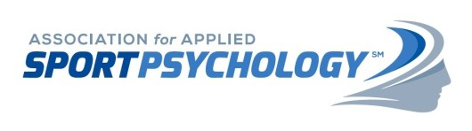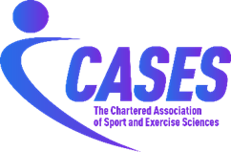

MEMORANDUM OF UNDERSTANDING

A partnership between

The Association for Applied Sport Psychology
and
The Chartered Association of Sport and Exercise Sciences

- Objective
  - This Memorandum of Understanding (MoU) outlines the agreed collaborative relationship between the Association for Applied Sport Psychology (AASP) and the Chartered Association of Sport and Exercise Sciences (CASES) for the purposes of enhancing the activities of each organisation and fostering co-operation in international context for the benefit of all professionals involved within the respective organisations.

  - The original MoU was signed in February 2020. This updated MoU follows a meeting between AASP and CASES on 21 February 2023 where an agreement was made to extend the existing MoU for a further three years, until 31 December 2025.

- Background
  - AASP promotes science and ethical practice in the field of sport and performance psychology and offers accredited certification to qualified professionals. AASP supports people at every age and level across the performance spectrum – including sport, exercise, tactical, business, and performing arts populations – and elevate their ability to perform and thrive.

  - CASES is the professional body for sport and exercise sciences in the United Kingdom. CASES’ mission is to promote excellence in sport and exercise sciences through evidence-based practice.

- Collaboration
  - CASES will provide AASP members with free access to the following resources:
    - The full back catalogue of CASES quarterly publication, The Sport and Exercise Scientist, in addition to all new issues published during the lifetime of this agreement.
    - The full archive of CASES Expert Statements (47).

  - AASP will provide CASES members with full, free access to the following resources:
    - Online access to Case Studies in Sport and Performance Psychology (CSSPP), including the full archive and all new issues published during the lifetime of this agreement.

  - AASP and CASES agree to run a minimum of one collaborative professional development event (e.g., webinar, workshop) every two years, to be co-ordinated by the respective CPD officers or other appropriate representatives from each organisation.

- Review
  - Both parties commit to at least one partnership review meeting per year. Within these meetings, the review of existing partnership arrangements will take place, as well as examining scope for further expansion of the partnership.

  - The MoU can be amended at any point by unanimous agreement.

- Confidentiality
  - Both parties commit to complying with any applicable privacy legislation in their jurisdiction regarding any personal information they receive about the members of the partner organisation. This provision will survive termination of this MoU.

  - Both parties agree not to disclose any information or documents which comes to its knowledge or into its possession by reason of this MoU which the other partner organisation has explicitly or implicitly indicated as confidential unless otherwise pursuant to judicial or legislative authority in the respective jurisdiction. This provision will survive termination of this MoU.

- Term
  - This MoU will last until 31 December 2025. CASES and AASP will evaluate this agreement mid-term and determine whether to extend the terms for another three (3) years, ending 31 December 2028.

For AASP  Name: Kent Lindeman CMP  Post: Executive Director  Date: 5/5/23 | 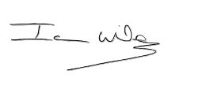For CASES  Name: Ian Wilson  Post: Chief Executive Officer  Date: 6 May 2023

